Learning objectives
- Part 1: Understand what controls viscosity, and the relative effect of water, temperature, and composition
- Part 2: Understand the concept of a liquidus, and play around with parameters that control the liquidus phase.
- Part 3: Understand the influence of oxygen fugacity and water content on the development of tholeiitic vs. calc alkaline magmas.
Part 1 – What affects viscosity
We are using the Giordano et al. Viscosity model in the python package Thermobar to calculate viscosity.
1a. What is the viscosity of the basaltic composition at 1150C with 0 wt% H2O?
~104 PaS
1b. Now increase the water content to 3 wt%. How much does viscosity change?
Now its 8.77 PaS, adding water drastically reduces viscosity
1c. Now of course, adding water means in reality, the temperature has probably gone down (if you have any crystals around). The liquidus temperature decreases by ~10℃ per 1 wt% water added (Putirka, 2008). So now run the calculation again, but adjusting the temperature to account for this. Does decreasing temp cancel out adding water?
Running at 1120 C gives 13.1 PaS, so adding water still dominates.
1d. Now perform the calculation for the rhyolite also at 1150C, with no water initially. Temp and water is the same – what is making the rhyolite more viscous?
783172.182239 PaS! Its higher SiO₂ content is responsible
1e. A more reasonable Rhyolite Temperature is 850C. What is the viscosity with no water?
4.337321e+09PaS! Much lower than before
1f. What temperature and/or water contents do you need to get the viscosity back to the 100s of PaS like the basalt? Is this at all plausible?
Need 1800+C if no water. Not plausible. Shows the very large difference in viscosity arising from the melt composition term. If 6 wt% water, need 1200C still. Still way to hot for a rhyolite. So a rhyolite will never have the viscosity of a basalt.
Part 2 – Calculating melt liquidus temperatures
2a – What is the liquidus temperature and liquidus phase for the basaltic bulk composition with no H2O at 1000 bars?
1199.7 C and plagioclase
2b – Now calculate the liquidus at 5000 bars
1269C and Cpx.
2c – Why is the liquidus at a higher temperature at higher pressure?
Higher pressures favors the phase with the smaller volume, which is the mineral (or solid in this case), as this is denser than the liquid. Can also make the argument based on the Clapeyron slope.
2d – How does the liquidus phase change as you change the water content and pressure? Try 4 different pressure and water content combinations and see what phases you get.
If add 4 wt% water and 1 kbar, get olivine instead. If increase pressure with no water, get Cpx.
2e – Now calculate the liquidus phase and assemblage for the rhyolite at 1000 bars, 0 wt% H2O
1033 C and plagioclase
2d –lets use the equilibrate_multi function to look at what phases are present 60 degrees below the liquids you calculated for 1200C, 1000 bars, with 0.0001 and 1 wt% H2O
1 wt% H2O = Liq and Cpx.
0.0001 wt% H2O = Liq, Cpx Cpx2 and Plag.
2e –Lets calculate the viscosity for this system now vs. the viscosity at the liquidus!
174 PaS for 0.0001– has increased from 57 PaS. So became more viscous during fractional crystallization. Due to temperature drop.
Part 3 – Lets investigate how phase stability and liquid lines of descent change as a function of oxygen fugacity, achieved here by varying Fe3/FeT in the melt
3a- Look at the major element plots – what are the biggest changes between different models?
SiO2, TiO2 and FeO
3a – Looking at the phase abundance plots, what is the biggest difference between FMQ-1 and FMQ+2? What is the chemistry of these phases – and why do they cause SiO2 to go up?
The appearance of rhm – and Sp (rhombohedral oxides and spinels) – These are your Fe-Ti oxides. You will see in FMQ-1, they appear at ~2 wt% MgO, at FMQ+2 at ~5-6 wt%. These are very poor in SiO2, so as you fractionate them, you increase SiO₂ in the residual melt. You also deplete FeO and TiO2 very quickly as these are major constituents of these phases.
Part 4 – Lets investigate how phase stability and liquid lines of descent change as a function of water content
We are going to be using the isobaric_crystallization function, Lets run at 0.5, 2, 4 wt % water at 2 kbar.
4a) What major elements show the biggest differences between models run at different water contents?
TiO2, FeOt
4b) What is the liquidus phase and dominant phases present at each water content?
At 0.5 wt%, Liq phase = Cpx, Cpx and Plag are dominant phases, with a little bit of spinel.
At 2 wt%, Liq phase = Cpx, Cpx and Plag are still dominant, but see a bit more spinel and Opx coming on
At 4 wt%, Liq phase = Ol, Then Cpx dominant, plag only comes on later, more spinels phases form as it evolves
4c) Change the x axis to be temperature – what happens to the abundance of solid phases at each temperature?
As you add more water, you get less and less solid at a given temperature. This is because the liquidus has been depressed by the addition of water, so more melt can exist in a cooler system.
4d) The Calc alkaline vs. tholeiitic magma series is typically classified after Miyashiro et al. (1974) in SiO2 vs. FeO/MgO space. Calc alkaline magmas show early Fe removal, Tholeiitic magmas show Fe enrichment during early differentiation.
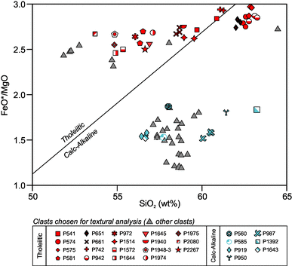
First, lets look at a plot of the water series in this space – Do any of them cross into the calc-alkaline field?
The driest line (blue) shows very strong iron enrichment, shooting up into the Tholeiitic field. The 2 and 4 wt% show less strong Fe enrichment, but do not cross into the Calc alkaline field. Instead, they parallel it.
4e) Now make the same plot for the fo2 series – Screenshot your plot below and comment on it 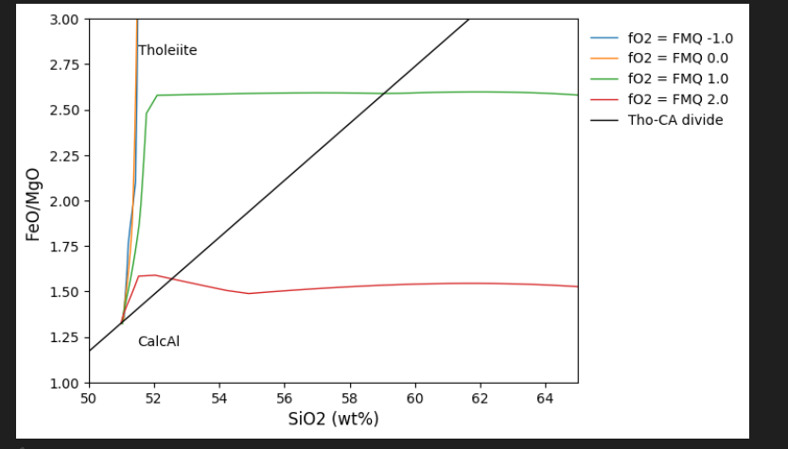
The most oxidised calculation runs in to the calc alkaline field immediately, the FMQ+1 also does.
4f) From these two comparisons – what conditions can you conclude favour the formation of calc alkaline vs. tholeiitic lavas? Using the lecture slides so far, what tectonic setting should this occur in?
Higher water contents and higher oxygen fugacities – Characteristic of arc lavas!

